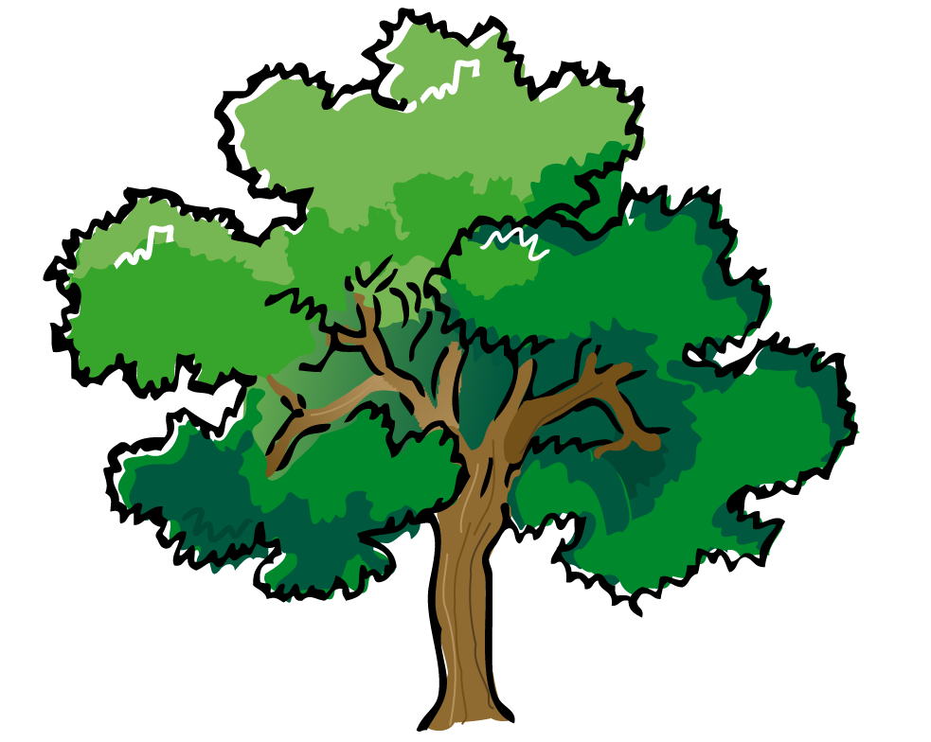
Welcome to Seventh Grade Science!

Ms. Amy Woolf
Contact:
amy_woolf@hcpss.org (best)
OMMS Phone #: (410) 313-6937
Class website: mswoolfscience.weebly.com

I am very excited to begin the 2014-2015 school year. This year in science we will be learning Life Science. Life science has to do with all living things around us, including our friends and families! The class will be broken up into four units. As a class we will investigate the nature of living things (quarter one), the human body (quarter two), genetics (quarter three), and evidence of change and ecology (quarter four). Please find classroom policies highlighted below:

Five Class Expectations:
- Be Positive
- Be Engaged
- Be Responsible
- Show Respect
- Do your Best

Materials:
- Binder section dedicated to Science
- Pen and Pencils
- Colored pencils
- Glue stick
- Highlighters
- Scissors

Textbook:
Every student will receive a textbook and it is his or her responsibility for the entire year. If the textbook is not returned in the same condition it was received (or goes missing) the student is responsible to pay to have the book replaced.

Absences:
It is the students’ responsibility to make up any missed work from excused absences. The student is responsible for contacting the teacher in order to receive make-up work. Students are allowed the same number of days that they are absent in order to make-up work and assessments in order to receive full credit.

Homework:
Homework will be assigned regularly in order to build on concepts learned in class. Not all assigned homework will be written assignments. Students are expected to review their class materials regularly.

Grading Policy:
50% Assessments: Tests, Projects, announced Quizzes, select Labs
40% Classwork (this includes activities started in class and finished at home): activities, mini-projects, notebook/binder checks, labs, and unannounced quizzes
10% Homework
* Homework is due at the beginning of the period. Homework that is late will not receive full credit, homework left in lockers is considered late.

SPECIAL OFFER: Each quarter, students will have an opportunity to resubmit one classwork or homework assignment for a better grade. In order to take advantage of this opportunity, students will need to be up to date with all assignments from that quarter (meaning no missing assignments). Please see Ms. Woolf if you have any questions.

Technology Responsibilities:
In this classroom we will use technology. We will be using computers, lab equipment, online resources, a class website and a class website. It is very important that you use all technology with responsibility and maturity. When using computers or other equipment it is important to use them for the intended use. When using new programs it is important to learn to properly use them. I will model behavior that I expect to see from all students. If you have any questions about how to use sources properly please do not hesitate to ask. Using technology in the 21st century is a skill we will be building this year.

Please keep this letter in your binder to use as a reference throughout the school year. I’m looking forward to getting to know you!

Please sign the space below to indicate that you have read through the class outline with your parent/guardian.

_______________________________________________________________________________
Student Signature

_______________________________________________________________________________
Parent Signature (and printed name)

